
WDT Project

Dijkstra Algorithm Analysis

For Egy Metro Guide Project

Member name | ID
Abd Alrahman Saed Alsayed | 202302377
Mahmoud Mohamed Hegazy | 202302612
Mahmoud Fawzy Mahmoud | 202302484
Ali Yasser Mohamed | 202305666
Abdullah Ibrahiem Gaballah | 202302701

Supervised by: Dr Hossam Eladly

1. Introduction
In transportation applications such as metro navigation systems, users need to find the shortest or fastest route between two stations. This problem is commonly solved using graph algorithms. One of the most famous algorithms used for this purpose is the Dijkstra Algorithm.
The Dijkstra algorithm is used to find the shortest path between nodes in a graph. In the case of a metro system, each station can be represented as a node, and the distance between stations can be represented as edges with weights.
In the Egy Metro Guide project, the Dijkstra algorithm will be used to calculate the shortest path between two metro stations selected by the user.

2. What is Dijkstra Algorithm?
The Dijkstra Algorithm is a graph search algorithm developed by the computer scientist Edsger W. Dijkstra in 1956.
It is used to find the shortest path from a source node to all other nodes in a weighted graph, where all edge weights are non-negative.
In simple terms, the algorithm helps determine the minimum distance from one point to another.
For example in a metro system:
- Stations = Nodes
- Metro connections = Edges
- Distance or travel time = Weight
The algorithm then calculates the shortest route between stations.

3. How Dijkstra Algorithm Works
The algorithm works by exploring the graph step by step and always choosing the node with the smallest known distance.
The steps of the algorithm are:
- Set the starting station distance to 0.
- Set all other station distances to infinity.
- Mark all stations as unvisited.
- Select the unvisited station with the smallest distance.
- Update the distances of neighboring stations.
- Mark the current station as visited.
- Repeat until the destination station is reached.
The algorithm guarantees that the first time we reach a node with the smallest distance, we have already found the optimal shortest path.

4. Graph Representation in Metro Systems
In the Egy Metro Guide project, the metro network will be modeled as a graph.
Graph components:
Nodes (Vertices)
Represent metro stations such as:
- Helwan
- Sadat
- El Shohadaa
- New El Marg

Edges
Represent direct connections between stations.
Weights
Represent distance or travel time between stations.
Example:
Helwan → Ain Helwan → Helwan University → Wadi Hof → ... → Sadat
Each connection has a cost such as:
- Distance
- Travel time
- Number of stations

5. Why Dijkstra is Suitable for Metro Systems
Dijkstra algorithm is suitable for metro applications because:
- It finds the shortest path efficiently.
- It works well with weighted graphs.
- It guarantees the optimal route.
- It is widely used in navigation systems such as Google Maps.
For metro systems where travel between stations has a fixed cost, Dijkstra is a reliable solution.

6. Time Complexity
The time complexity of Dijkstra depends on the implementation.
Using a simple implementation:
Time Complexity =
O(V²)
Where:
V = Number of stations (vertices)
Using a Priority Queue (Min Heap):
Time Complexity =
O((V + E) log V)
Where:
V = Number of stations
E = Number of connections between stations
This makes the algorithm efficient even for large transportation networks.

7. Implementation of Dijkstra Algorithm using C#
Since the Egy Metro Guide project will be developed using ASP.NET, the Dijkstra Algorithm can be implemented directly using C# in the backend.
Using C# allows the algorithm to integrate easily with the ASP.NET application without the need for external services or additional programming languages.
C# provides several useful data structures that make implementing the algorithm easier, such as:
- List
- Dictionary
- PriorityQueue
These data structures help efficiently manage stations, connections, and distance calculations.
Exampe implementation in C#:
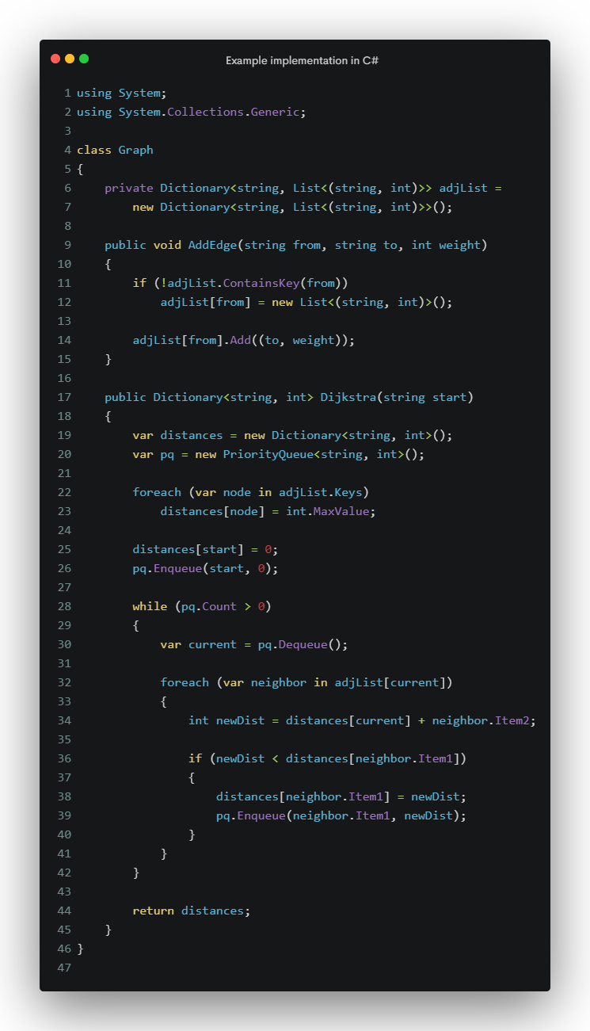
This code calculates the shortest distances from a starting station to all other stations.

8. Integration with Egy Metro Guide
In the Egy Metro Guide web application, the algorithm will be used as follows:
- User selects:
  - Start Station
  - Destination Station
- The application sends the request to the backend.
- The backend runs the Dijkstra Algorithm on the metro graph.
- The algorithm calculates the shortest route.
- The system returns:
- Shortest path
- Number of stations
- Estimated travel distance
Example output:
Start: Helwan
Destination: Sadat
Route:
Helwan → Ain Helwan → Helwan University → Wadi Hof → ... → Sadat

9. Advantages of Using Dijkstra
- Efficient shortest path calculation
- Suitable for transportation systems
- Works well with weighted graphs
- Easy to implement in C#
- Reliable and widely used in real world navigation systems

10. Conclusion
The Dijkstra Algorithm is an essential algorithm for solving shortest path problems in graphs. In the Egy Metro Guide project, it plays a critical role in helping users find the optimal route between metro stations.
By representing the metro network as a graph and applying the algorithm, the system can efficiently calculate the best route for passengers.
Using C# implementation within ASP.NET allows the algorithm to integrate smoothly with the web application backend, making the system efficient and scalable.

